**Table S1.** Tests of precision and accuracy of Mg isotope analyses

|  |  |  |  |  |  |
| --- | --- | --- | --- | --- | --- |
| Sample | δ26Mg | 2σ | δ25Mg | 2σ | N |
| **Pure Mg solution in this study** |  |  |  |  |  |
| Cambridge 1 | -2.56 | 0.07 | -1.30 | 0.02 | 8 |
| DSM3 | 0.05 | 0.07 | 0.03 | 0.05 | 8 |
|  |  |  |  |  |  |
| **Standard Samples** |  |  |  |  |  |
| IAPSO seawater | -0.81 | 0.03 | -0.41 | 0.04 | 2 |
| DST-2b | -0.28 | 0.05 | -0.15 | 0.04 | 4 |
| BHVO-2b | -0.28 | 0.11 | -0.15 | 0.06 | 2 |
|  |  |  |  |  |  |
| **Reference** |  |  |  |  |  |
| Cambridge 1 (An and Huang, 2014) | -2.597 | 0.042 | -1.343 | 0.036 | 49 |
| Cambridge 1 (Teng et al., 2015) | -2.623 | 0.03 | -1.358 | 0.03 | ﹥20 |
| DSM3 (Tipper et al., 2010) | 0 | 0.05 | 0 | 0.03 | 100 |
| DSM3 (Li et al., 2012) | 0.02 | 0.13 | 0 | 0.09 | 109 |
| IAPSO seawater (Teng et al., 2015) | -0.83 | 0.09 | -0.42 | 0.06 | ﹥20 |
| Seawater (Ling et al., 2011) | -0.832 | 0.068 | -0.432 | 0.053 | 40 |
| BHVO-2b (Teng, 2017) | -0.24 | 0.08 | -0.12 | 0.05 |  |
| DST-2b (Bizzarro et al., 2011)) | -0.23 | 0.03 | -0.12 | 0.02 | 7 |
| DST-2b (Teng et al., 2015) | -0.32 | 0.06 | -0.17 | 0.04 | ﹥20 |

Reference:

An, Y., Huang, F., 2014. A review of Mg isotope analytical methods by MC-ICP-MS. Journal of Earth Science 25, 822-840.

Bizzarro, M., Paton, C., Larsen, K., Schiller, M., Trinquier, A., Ulfbeck, D., 2011. High-precision Mg-isotope measurements of terrestrial and extraterrestrial material by HR-MC-ICPMS—implications for the relative and absolute Mg-isotope composition of the bulk silicate Earth. Journal of Analytical Atomic Spectrometry 26, 565.

Li, W., Chakraborty, S., Beard, B.L., Romanek, C.S., Johnson, C.M., 2012. Magnesium isotope fractionation during precipitation of inorganic calcite under laboratory conditions. Earth and Planetary Science Letters 333-334, 304-316.

Ling, M.X., Sedaghatpour, F., Teng, F.Z., Hays, P.D., Strauss, J., Sun, W., 2011. Homogeneous magnesium isotopic composition of seawater: an excellent geostandard for Mg isotope analysis. Rapid communications in mass spectrometry : RCM 25, 2828-2836.

Teng, F.-Z., 2017. Magnesium Isotope Geochemistry. Reviews in Mineralogy and Geochemistry 82, 219-287.

Teng, F.-Z., Li, W.-Y., Ke, S., Yang, W., Liu, S.-A., Sedaghatpour, F., Wang, S.-J., Huang, K.-J., Hu, Y., Ling, M.-X., Xiao, Y., Liu, X.-M., Li, X.-W., Gu, H.-O., Sio, C.K., Wallace, D.A., Su, B.-X., Zhao, L., Chamberlin, J., Harrington, M., Brewer, A., 2015. Magnesium Isotopic Compositions of International Geological Reference Materials. Geostandards and Geoanalytical Research 39, 329-339.

Tipper, E.T., Gaillardet, J., Louvat, P., Capmas, F., White, A.F., 2010. Mg isotope constraints on soil pore-fluid chemistry: Evidence from Santa Cruz, California. Geochimica et Cosmochimica Acta 74, 3883-3896.

**Table S2.** The results of XRD analyses for the carbonate in Quse Formation

|  |  |  |  |  |  |  |  |
| --- | --- | --- | --- | --- | --- | --- | --- |
| Sample Number | Depth/m | mineral contents | | | calcite | dolomite | |
| quartz | calcite | dolomite | d (104) | d (104) | (104) FWHM |
| 1 | 63 | 0.0 | 1.9 | 98.1 | 3.0291 | 2.9018 | 0.209 |
| 2 | 64 | 0.0 | 3.6 | 96.4 | 3.0347 | 2.9017 | 0.229 |
| 3 | 65 | 0.0 | 9.8 | 90.2 | 3.0366 | 2.8965 | 0.246 |
| 4 | 66 | 0.0 | 1.2 | 98.8 | 3.0348 | 2.8947 | 0.277 |
| 5 | 67 | 0.0 | 14.3 | 85.7 | 3.0367 | 2.9018 | 0.232 |
| 6 | 69 | 0.0 | 9.7 | 90.3 | 3.035 | 2.9017 | 0.237 |
| 7 | 70 | 0.0 | 1.3 | 98.7 | 3.0327 | 2.9018 | 0.23 |
| 8 | 72 | 0.0 | 1.7 | 98.3 | 3.031 | 2.9034 | 0.226 |
| 9 | 76 | 0.0 | 0.8 | 99.2 | 3.029 | 2.9016 | 0.238 |
| 10 | 79 | 0.0 | 18.0 | 82.0 | 3.0349 | 2.9017 | 0.229 |
| 11 | 82 | 0.0 | 3.4 | 96.6 | 3.0348 | 2.9017 | 0.222 |
| 12 | 84 | 0.0 | 10.3 | 89.7 | 3.0349 | 2.9018 | 0.217 |
| 13 | 87 | 0.0 | 6.3 | 93.7 | 3.0366 | 2.9018 | 0.212 |
| 14 | 90 | 0.0 | 10.2 | 89.8 | 3.0349 | 2.9017 | 0.212 |
| 15 | 95 | 0.0 | 25.5 | 74.5 | 3.0347 | 2.9018 | 0.183 |
| 16 | 97 | 0.0 | 4.1 | 95.9 | 3.0331 | 2.9034 | 0.188 |
| 17 | 99 | 0.0 | 12.1 | 87.9 | 3.0348 | 2.9017 | 0.192 |
| 18 | 100 | 0.0 | 33.4 | 66.6 | 3.0349 | 2.9017 | 0.222 |
| 19 | 101 | 0.0 | 4.2 | 95.8 | 3.033 | 2.9016 | 0.204 |
| 20 | 103 | 0.0 | 15.4 | 84.6 | 3.0348 | 2.9018 | 0.181 |
| 21 | 104 | 0.0 | 32.5 | 67.5 | 3.0348 | 2.9015 | 0.24 |
| 22 | 105 | 0.0 | 5.4 | 94.6 | 3.0311 | 2.9017 | 0.194 |
| 23 | 106 | 0.0 | 5.6 | 94.4 | 3.033 | 2.9018 | 0.194 |
| 24 | 107 | 0.0 | 6.1 | 93.9 | 3.0348 | 2.9017 | 0.175 |
| 25 | 109 | 0.0 | 8.9 | 91.1 | 3.0349 | 2.9017 | 0.216 |
| 26 | 111 | 0.0 | 12.4 | 87.6 | 3.0348 | 2.9015 | 0.221 |
| 27 | 113 | 0.0 | 14.4 | 85.6 | 3.0349 | 2.9017 | 0.188 |
| 28 | 115 | 0.0 | 22.6 | 77.4 | 3.0349 | 2.9018 | 0.178 |
| 29 | 119 | 0.0 | 2.7 | 97.3 | 3.0292 | 2.9015 | 0.196 |
| 30 | 122 | 0.0 | 1.8 | 98.2 | 3.0329 | 2.9017 | 0.203 |
| 31 | 126 | 0.0 | 6.4 | 93.6 | 3.0349 | 2.8948 | 0.236 |
| 32 | 127 | 0.0 | 3.9 | 96.1 | 3.0348 | 2.8947 | 0.236 |
| 33 | 128 | 0.0 | 12.4 | 87.6 | 3.0349 | 2.8948 | 0.23 |
| 34 | 129 | 0.0 | 2.1 | 97.9 | 3.0364 | 2.9017 | 0.136 |
| 35 | 130 | 0.0 | 2.3 | 97.7 | 3.0348 | 2.9016 | 0.162 |
| 36 | 131 | 0.0 | 2.0 | 98.0 | 3.033 | 2.8948 | 0.247 |
| 37 | 132 | 0.0 | 2.3 | 97.7 | 3.0346 | 2.8947 | 0.246 |
| 38 | 133 | 0.0 | 3.2 | 96.8 | 3.0348 | 2.8928 | 0.22 |
| 39 | 134 | 0.0 | 2.9 | 97.1 | 3.0348 | 2.9016 | 0.227 |
| 40 | 1 | 2.9 | 95.2 | 1.9 | 3.0309 | 2.9019 | 0.156 |
| 41 | 11 | 1.8 | 90.4 | 7.8 | 3.0309 | 2.9068 | 0.159 |
| 42 | 21 | 2.5 | 90.8 | 6.7 | 3.0291 | 2.9036 | 0.171 |
| 43 | 31 | 1.9 | 94.7 | 3.4 | 3.0309 | 2.9053 | 0.168 |
| 44 | 41 | 1.3 | 95.6 | 3.0 | 3.0329 | 2.9053 | 0.146 |
| 45 | 51 | 2.8 | 97.2 | 0.0 | 3.0309 |  | 0.216 |
| 46 | 55 | 1.9 | 96.0 | 2.0 | 3.031 | 2.9054 | 0.169 |

**Table S3.** The trace element compositions in the carbonates in Quse Formation

|  |  |  |  |  |  |  |  |  |  |  |  |  |  |  |  |  |  |
| --- | --- | --- | --- | --- | --- | --- | --- | --- | --- | --- | --- | --- | --- | --- | --- | --- | --- |
| Sample Number | Depth/m | concentration/ppm | | | | | | | | | | | | | | | |
| Li | Sc | Ti | V | Cr | Mn | Co | Ni | Cu | Zn | Rb | Sr | Mo | Cd | Ba | U |
| 1 | 63 | 2.47 | 0.40 | 6.04 | 4.08 | 3.73 | 67.28 | 1.49 | 11.65 | 1.48 | 96.01 | 0.70 | 113.70 | 0.24 | 0.19 | 3.12 | 1.32 |
| 2 | 64 | 2.10 | 0.43 | 6.00 | 6.85 | 4.56 | 101.53 | 1.66 | 12.83 | 2.02 | 118.31 | 0.66 | 103.09 | 0.18 | 0.24 | 3.12 | 1.13 |
| 3 | 65 | 1.48 | 0.43 | 5.25 | 6.25 | 4.36 | 92.47 | 1.46 | 11.72 | 1.51 | 90.94 | 0.88 | 92.32 | 0.16 | 0.18 | 2.87 | 0.87 |
| 4 | 66 | 1.62 | 0.22 | 4.76 | 2.93 | 3.87 | 62.86 | 1.35 | 10.73 | 1.22 | 76.67 | 0.42 | 91.46 | 0.14 | 0.14 | 2.64 | 1.06 |
| 5 | 67 | 1.27 | 0.43 | 4.84 | 3.52 | 4.16 | 92.02 | 1.44 | 11.47 | 1.37 | 69.83 | 0.78 | 93.26 | 0.11 | 0.17 | 2.82 | 0.93 |
| 6 | 69 | 1.47 | 0.51 | 6.18 | 3.92 | 4.43 | 83.20 | 1.55 | 12.11 | 1.48 | 103.61 | 0.80 | 100.55 | 0.14 | 0.19 | 3.18 | 1.02 |
| 7 | 70 | 1.60 | 0.38 | 6.77 | 4.09 | 3.52 | 78.98 | 1.62 | 12.59 | 1.78 | 139.36 | 0.57 | 98.42 | 0.13 | 0.27 | 2.84 | 0.99 |
| 8 | 72 | 1.90 | 0.41 | 7.33 | 4.48 | 4.61 | 55.94 | 1.76 | 13.11 | 2.18 | 88.12 | 0.71 | 115.61 | 0.16 | 0.17 | 3.36 | 1.14 |
| 9 | 76 | 2.42 | 0.90 | 9.37 | 5.49 | 4.79 | 63.96 | 1.69 | 12.42 | 2.05 | 101.78 | 1.49 | 119.20 | 0.15 | 0.20 | 4.76 | 1.12 |
| 10 | 79 | 1.34 | 0.32 | 5.87 | 5.84 | 4.02 | 153.33 | 1.85 | 16.03 | 2.13 | 98.16 | 0.46 | 107.29 | 0.15 | 0.18 | 2.72 | 0.81 |
| 11 | 82 | 1.82 | 0.32 | 5.71 | 4.59 | 4.49 | 69.39 | 1.61 | 13.73 | 2.15 | 75.43 | 0.53 | 112.89 | 0.20 | 0.18 | 2.96 | 1.12 |
| 12 | 84 | 2.19 | 0.39 | 7.81 | 7.40 | 4.21 | 111.52 | 2.35 | 18.37 | 4.39 | 128.23 | 0.55 | 123.11 | 0.16 | 0.24 | 3.52 | 1.05 |
| 13 | 87 | 2.10 | 0.56 | 8.07 | 6.40 | 4.67 | 96.13 | 1.72 | 15.09 | 2.95 | 85.86 | 0.71 | 115.03 | 0.19 | 0.17 | 3.03 | 1.12 |
| 14 | 90 | 1.46 | 0.20 | 5.54 | 4.05 | 3.64 | 101.74 | 1.51 | 12.37 | 2.04 | 80.74 | 0.44 | 85.97 | 0.17 | 0.24 | 2.10 | 0.84 |
| 15 | 95 | 1.57 | 0.76 | 5.32 | 6.18 | 6.89 | 161.81 | 1.33 | 11.52 | 0.56 | 29.86 | 1.04 | 100.97 | 0.22 | 0.11 | 3.16 | 2.33 |
| 16 | 97 | 2.75 | 1.93 | 10.42 | 7.77 | 10.01 | 53.82 | 1.55 | 12.90 | 1.34 | 42.87 | 2.29 | 128.61 | 0.26 | 0.10 | 5.73 | 1.61 |
| 17 | 99 | 1.97 | 0.61 | 9.83 | 7.93 | 6.05 | 106.74 | 1.81 | 15.29 | 3.82 | 109.35 | 1.03 | 102.26 | 0.19 | 0.26 | 3.16 | 1.21 |
| 18 | 100 | 1.10 | 0.35 | 3.12 | 5.48 | 4.04 | 157.87 | 1.24 | 10.84 | 0.72 | 20.52 | 0.44 | 84.78 | 0.18 | 0.08 | 1.83 | 1.61 |
| 19 | 101 | 1.60 | 0.23 | 4.65 | 3.60 | 3.99 | 68.58 | 1.25 | 11.15 | 4.13 | 134.46 | 0.40 | 87.37 | 0.16 | 0.43 | 2.15 | 0.92 |
| 20 | 103 | 2.04 | 0.26 | 4.49 | 2.31 | 2.80 | 64.38 | 1.21 | 9.38 | 0.53 | 13.39 | 0.61 | 101.79 | 0.19 | 0.05 | 3.12 | 1.17 |
| 21 | 104 | 1.34 | 0.53 | 3.57 | 1.65 | 6.80 | 94.00 | 1.34 | 11.97 | 0.50 | 13.00 | 0.28 | 88.42 | 0.21 | 0.05 | 2.18 | 1.16 |
| 22 | 105 | 2.46 | 0.80 | 8.85 | 3.90 | 5.75 | 58.56 | 1.13 | 9.86 | 0.92 | 22.26 | 0.95 | 115.79 | 0.23 | 0.05 | 3.81 | 1.13 |
| 23 | 106 | 2.32 | 0.78 | 8.79 | 5.01 | 5.13 | 81.13 | 1.44 | 11.95 | 2.23 | 52.94 | 1.14 | 113.65 | 0.23 | 0.11 | 4.39 | 1.06 |
| 24 | 107 | 2.49 | 0.80 | 5.57 | 3.08 | 8.31 | 57.41 | 1.08 | 9.62 | 0.44 | 18.86 | 0.76 | 122.52 | 0.27 | 0.04 | 4.16 | 1.08 |
| 25 | 109 | 2.05 | 0.50 | 6.97 | 3.47 | 5.22 | 68.04 | 1.18 | 10.81 | 0.94 | 52.10 | 0.79 | 113.01 | 0.19 | 0.16 | 2.58 | 0.88 |
| 26 | 111 | 1.85 | 0.37 | 6.07 | 4.09 | 4.88 | 97.86 | 1.41 | 11.83 | 1.22 | 59.78 | 0.61 | 106.83 | 0.20 | 0.15 | 5.95 | 0.86 |
| 27 | 113 | 2.40 | 0.71 | 9.92 | 5.74 | 7.62 | 112.45 | 1.94 | 12.12 | 1.82 | 57.49 | 1.33 | 105.62 | 0.26 | 0.14 | 9.72 | 0.99 |
| 28 | 115 | 2.22 | 0.50 | 6.80 | 5.51 | 5.17 | 95.33 | 1.50 | 13.03 | 0.65 | 22.11 | 0.88 | 109.29 | 0.27 | 0.06 | 3.54 | 1.28 |
| 29 | 119 | 2.24 | 0.30 | 12.35 | 11.42 | 5.57 | 68.95 | 1.54 | 14.96 | 4.15 | 94.97 | 0.70 | 104.49 | 0.27 | 0.20 | 3.19 | 1.05 |
| 30 | 122 | 2.86 | 0.16 | 5.72 | 6.87 | 3.89 | 92.15 | 1.27 | 12.42 | 2.24 | 61.83 | 0.43 | 120.26 | 0.23 | 0.08 | 2.32 | 1.26 |
| 31 | 126 | 2.54 | 0.05 | 3.10 | 8.41 | 3.81 | 178.07 | 1.35 | 11.30 | 1.06 | 47.61 | 0.18 | 105.81 | 0.18 | 0.10 | 2.31 | 1.28 |
| 32 | 127 | 2.41 | 0.13 | 5.45 | 10.88 | 5.60 | 142.99 | 1.40 | 13.49 | 2.89 | 81.58 | 0.18 | 102.06 | 0.15 | 0.16 | 2.37 | 1.19 |
| 33 | 128 | 2.36 | 0.03 | 2.93 | 8.41 | 4.41 | 194.86 | 1.34 | 11.97 | 1.39 | 51.43 | 0.15 | 107.14 | 0.20 | 0.11 | 2.17 | 1.13 |
| 34 | 129 | 2.10 | 0.40 | 9.40 | 9.80 | 5.00 | 80.24 | 1.20 | 11.80 | 2.40 | 40.38 | 0.70 | 104.30 | 0.20 | 0.10 | 2.80 | 1.50 |
| 35 | 130 | 2.16 | 0.09 | 6.26 | 6.55 | 3.51 | 105.18 | 1.19 | 11.66 | 1.84 | 31.52 | 0.35 | 106.70 | 0.21 | 0.05 | 2.18 | 1.40 |
| 36 | 131 | 1.87 | 0.17 | 6.77 | 9.58 | 3.23 | 81.68 | 1.25 | 11.74 | 3.46 | 27.97 | 0.33 | 92.21 | 0.18 | 0.05 | 1.82 | 1.15 |
| 37 | 132 | 1.88 | 0.02 | 3.49 | 10.07 | 3.20 | 111.72 | 1.36 | 11.49 | 2.44 | 36.29 | 0.19 | 102.97 | 0.19 | 0.15 | 1.98 | 1.24 |
| 38 | 133 | 1.73 | 0.23 | 7.30 | 11.16 | 3.79 | 154.52 | 1.51 | 13.83 | 2.64 | 64.90 | 0.31 | 95.53 | 0.15 | 0.17 | 2.21 | 1.18 |
| 40 | 1 | 4.55 | 2.51 | 24.95 | 11.59 | 11.43 | 87.49 | 3.65 | 28.02 | 3.55 | 5.32 | 10.85 | 455.94 | 0.34 | 0.04 | 15.38 | 0.51 |
| 41 | 11 | 1.13 | 0.39 | 5.23 | 2.52 | 3.80 | 53.52 | 1.65 | 15.22 | 0.66 | 1.63 | 1.85 | 276.35 | 0.17 | 0.02 | 7.52 | 0.36 |
| 42 | 21 | 1.15 | 0.85 | 5.14 | 3.90 | 4.82 | 60.04 | 2.07 | 14.99 | 1.16 | 3.89 | 2.28 | 218.86 | 0.18 | 0.02 | 5.43 | 0.47 |
| 43 | 31 | 1.78 | 1.10 | 12.61 | 4.24 | 5.60 | 72.96 | 2.02 | 17.43 | 1.91 | 3.64 | 3.75 | 274.40 | 0.18 | 0.02 | 6.75 | 0.32 |
| 44 | 41 | 0.79 | 0.44 | 3.89 | 3.42 | 3.77 | 64.85 | 1.86 | 15.92 | 1.21 | 1.10 | 1.89 | 176.35 | 0.15 | 0.02 | 21.79 | 0.38 |
| 45 | 51 | 1.65 | 0.81 | 5.62 | 4.99 | 4.31 | 70.84 | 3.23 | 14.56 | 2.73 | 5.22 | 3.73 | 253.60 | 0.19 | 0.05 | 6.77 | 0.31 |
| 46 | 55 | 1.00 | 0.57 | 3.90 | 2.91 | 4.46 | 65.95 | 1.96 | 17.82 | 1.04 | 11.38 | 1.94 | 323.59 | 0.21 | 0.15 | 5.27 | 0.31 |

**Table S4.** C-O-Sr isotope compositions in the carbonate in Quse Formation

|  |  |  |  |  |  |  |  |
| --- | --- | --- | --- | --- | --- | --- | --- |
| Sample Number | Depth/m | 87Sr/86Sr | SE | δ13C | SE | δ18O | SE |
| 1 | 63 | 0.7075831 | 0.0000069 | 3.5 | 0.03 | -2.2 | 0.04 |
| 3 | 65 | 0.7078 | 0.0000073 | 3.1 | 0.02 | -5.4 | 0.04 |
| 5 | 67 | 0.7077808 | 0.0000067 | 3.2 | 0.01 | -4.9 | 0.03 |
| 7 | 70 | 0.7076315 | 0.0000066 | 3.7 | 0.03 | -3.7 | 0.04 |
| 9 | 76 | 0.707583 | 0.0000075 | 3.9 | 0.04 | -3.4 | 0.04 |
| 11 | 82 | 0.7075541 | 0.0000066 | 3.6 | 0.03 | -2.6 | 0.03 |
| 13 | 87 | 0.7075838 | 0.0000093 | 3.2 | 0.02 | -3.9 | 0.03 |
| 15 | 95 | 0.707825 | 0.0000079 | 2.7 | 0.02 | -4.5 | 0.04 |
| 17 | 99 | 0.7077591 | 0.0000074 |  |  |  |  |
| 19 | 101 | 0.7076306 | 0.0000073 | 3.0 | 0.02 | -3.5 | 0.04 |
| 20 | 103 | 0.7076076 | 0.0000082 | 2.9 | 0.03 | -2.6 | 0.04 |
| 22 | 105 | 0.7075504 | 0.0000075 | 3.3 | 0.02 | -2.6 | 0.02 |
| 24 | 107 | 0.7074985 | 0.0000072 | 3.4 | 0.03 | -2.6 | 0.03 |
| 26 | 111 | 0.7076531 | 0.0000066 | 2.6 | 0.04 | -4.6 | 0.04 |
| 28 | 115 | 0.70772 | 0.0000075 | 2.3 | 0.01 | -2.8 | 0.03 |
| 30 | 122 | 0.7075577 | 0.0000068 | 3.3 | 0.02 | -0.8 | 0.03 |
| 31 | 126 | 0.7076859 | 0.0000079 | 2.6 | 0.02 | -2.7 | 0.03 |
| 33 | 128 | 0.7077143 | 0.0000078 | 2.3 | 0.02 | -3.3 | 0.04 |
| 35 | 130 | 0.7075213 | 0.0000072 | 3.2 | 0.04 | -1.4 | 0.05 |
| 37 | 132 | 0.7075211 | 0.0000076 | 3.1 | 0.02 | -1.8 | 0.03 |
| 38 | 133 |  |  | 2.9 | 0.03 | -3.1 | 0.01 |
| 39 | 134 | 0.7076012 | 0.0000077 | 3.1 | 0.02 | -2.4 | 0.01 |
| 40 | 1 | 0.7077319 | 0.0000079 | 2.9 | 0.04 | -6.2 | 0.04 |
| 41 | 11 |  |  | 3.0 | 0.03 | -5.8 | 0.02 |
| 42 | 21 | 0.707597 | 0.0000069 | 2.8 | 0.02 | -6.4 | 0.01 |
| 43 | 31 |  |  | 2.7 | 0.03 | -5.7 | 0.02 |
| 44 | 41 | 0.7077089 | 0.0000078 | 1.9 | 0.02 | -9.5 | 0.02 |
| 45 | 51 |  |  | 2.6 | 0.02 | -4.5 | 0.02 |
| 46 | 55 | 0.7074816 | 0.0000078 | 2.6 | 0.02 | -4.3 | 0.03 |

**Table S5.** Mg isotope data for dolomite in dolostones in Quse Formation

|  |  |  |  |  |  |  |
| --- | --- | --- | --- | --- | --- | --- |
| Sample Number | Depth/m | δ26Mg | 2SD | δ25Mg | 2SD | n |
| 1 | 63 | -2.12 | 0.06 | -1.14 | 0.05 | 2 |
| 2 | 64 | -2.18 | 0.00 | -1.18 | 0.01 | 2 |
| 3 | 65 | -2.17 | 0.08 | -1.16 | 0.08 | 3 |
| 4 | 66 | -2.08 | 0.07 | -1.11 | 0.10 | 3 |
| 5 | 67 | -2.12 | 0.05 | -1.13 | 0.02 | 2 |
| 6 | 69 | -2.13 | 0.03 | -1.13 | 0.02 | 2 |
| 7 | 70 | -2.10 | 0.06 | -1.11 | 0.01 | 2 |
| 8 | 72 | -2.02 | 0.01 | -1.08 | 0.01 | 2 |
| 9 | 76 | -2.04 | 0.09 | -1.10 | 0.04 | 3 |
| 11 | 82 | -2.18 | 0.07 | -1.13 | 0.01 | 2 |
| 13 | 87 | -2.09 | 0.09 | -1.06 | 0.04 | 2 |
| 14 | 90 | -2.20 | 0.00 | -1.14 | 0.07 | 2 |
| 15 | 95 | -2.09 | 0.03 | -1.06 | 0.01 | 2 |
| 16 | 97 | -2.13 | 0.07 | -1.16 | 0.13 | 3 |
| 17 | 99 | -2.13 | 0.01 | -1.15 | 0.06 | 2 |
| 18 | 100 | -2.11 | 0.05 | -1.13 | 0.06 | 2 |
| 19 | 101 | -2.18 | 0.06 | -1.15 | 0.05 | 2 |
| 20 | 103 | -2.05 | 0.01 | -1.11 | 0.02 | 2 |
| 21 | 104 | -1.97 | 0.04 | -1.05 | 0.03 | 2 |
| 22 | 105 | -2.24 | 0.02 | -1.08 | 0.02 | 2 |
| 23 | 106 | -2.21 | 0.00 | -1.08 | 0.02 | 2 |
| 24 | 107 | -2.15 | 0.03 | -1.10 | 0.06 | 2 |
| 25 | 109 | -2.17 | 0.04 | -1.14 | 0.03 | 2 |
| 26 | 111 | -2.24 | 0.01 | -1.15 | 0.07 | 2 |
| 27 | 113 | -2.26 | 0.01 | -1.14 | 0.03 | 2 |
| 28 | 115 | -2.23 | 0.02 | -1.12 | 0.02 | 2 |
| 29 | 119 | -2.26 | 0.05 | -1.14 | 0.03 | 2 |
| 30 | 122 | -2.26 | 0.02 | -1.13 | 0.03 | 2 |
| 31 | 126 | -2.30 | 0.03 | -1.14 | 0.09 | 2 |
| 32 | 127 | -2.28 | 0.04 | -1.16 | 0.02 | 2 |
| 33 | 128 | -2.32 | 0.09 | -1.18 | 0.02 | 3 |
| 34 | 129 | -2.15 | 0.00 | -1.09 | 0.05 | 2 |
| 35 | 130 | -2.31 | 0.10 | -1.19 | 0.03 | 6 |
| 36 | 131 | -2.18 | 0.10 | -1.08 | 0.03 | 2 |
| 37 | 132 | -2.24 | 0.05 | -1.13 | 0.01 | 2 |
| 38 | 133 | -2.26 | 0.06 | -1.13 | 0.04 | 2 |
| 39 | 134 | -2.28 | 0.07 | -1.16 | 0.05 | 6 |

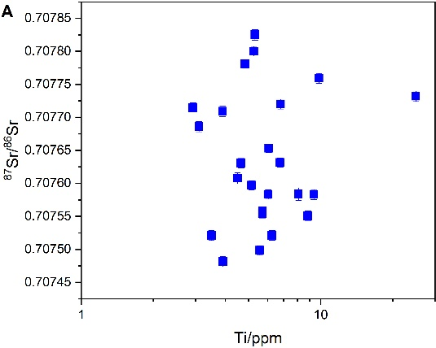 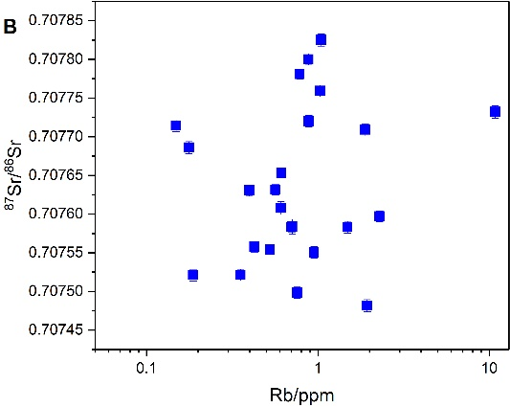

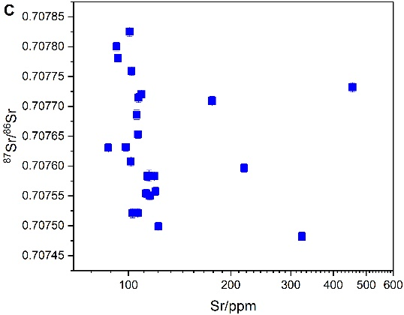

**Fig.S1.** The cross-plot showing the relationship between trace elements, and Sr isotope ratios. (A) The cross-plot between Ti contents and 87Sr/86Sr ratios; (B) The cross-plot between Rb contents and 87Sr/86Sr ratios; (C) The cross-plot between Sr contents and 87Sr/86Sr ratios.

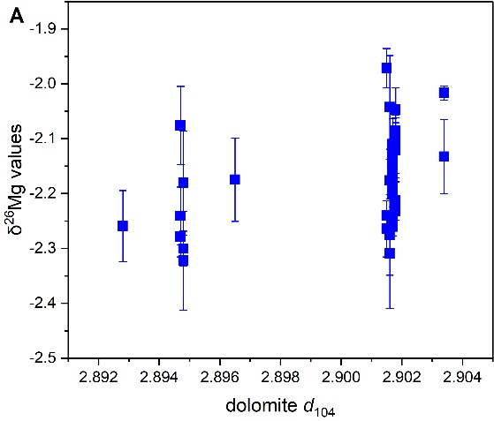 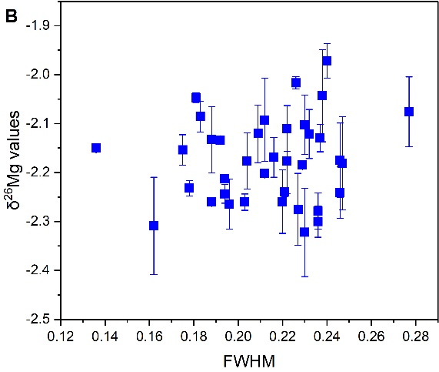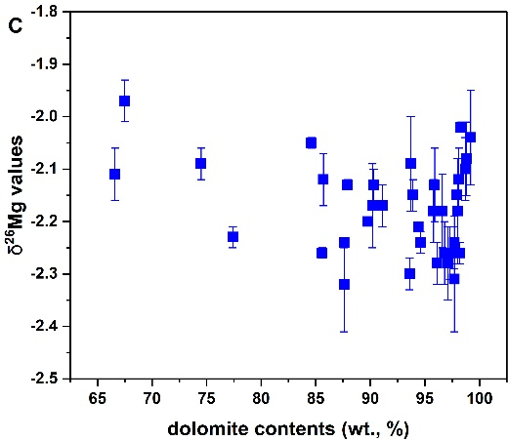

**Fig.S2.** The cross-plot showing the relationship between δ26Mg values and the parameters of dolomite lattice. (A) The cross-plot between δ26Mg values and *d*104 values; (B) The cross-plot between 26Mg values and the dolomite FWHM (104); (C) The cross-plot between δ26Mg values and dolomite contents in the bulk carbonates.